Prerequisites :-

* JDk
* Installed Jenkins with user account.
* Kubernetes cluster with master and worker node.
* Docker installed
* Docker hub account
* Github account with nodejs project and required files.

1. Open Jenkins and create a pipeline.

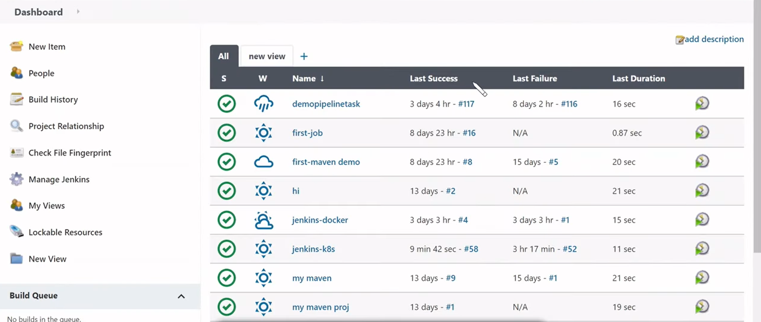

2. This is our Kubernetes cluster with master and slave node.

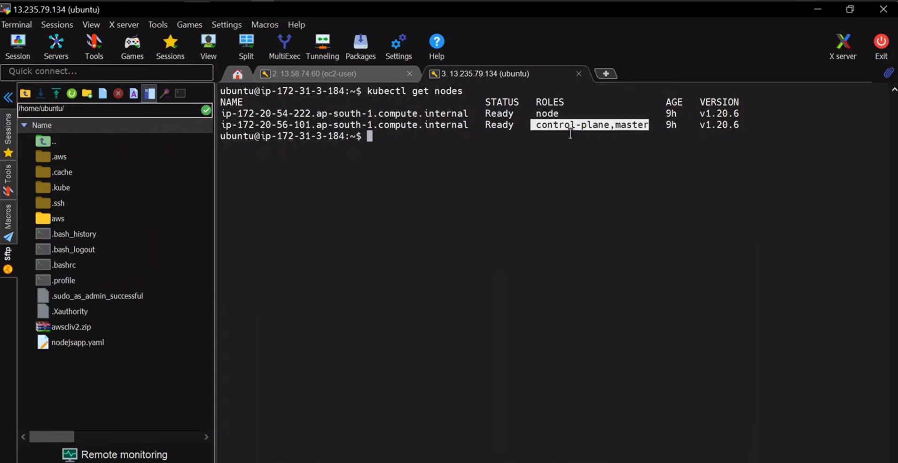

3.Now we need to download a ssh agent plugin to connect to Kubernetes cluster.

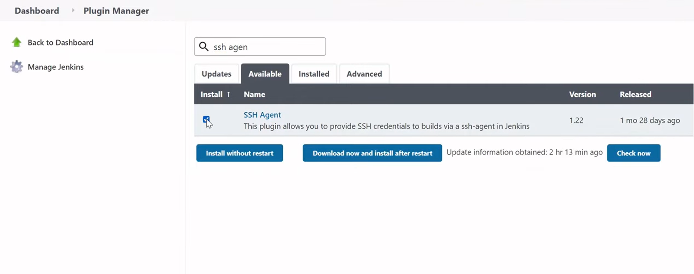

4.Now we need a see our docker hub from where we will pick our application image.

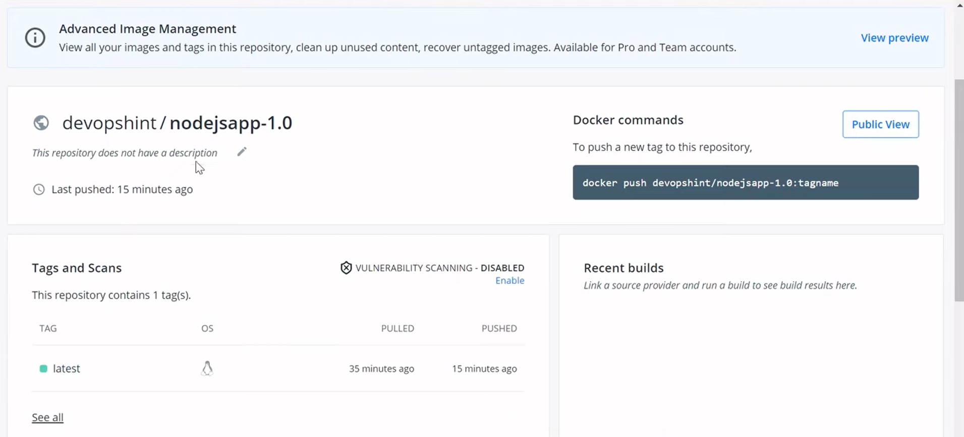

5. Now come back to your Jenkins pipeline(Jenkins-k8s) and configure it.

Provide the github link which contain all the files and application . It contains jenkinsfile and dockerfile.

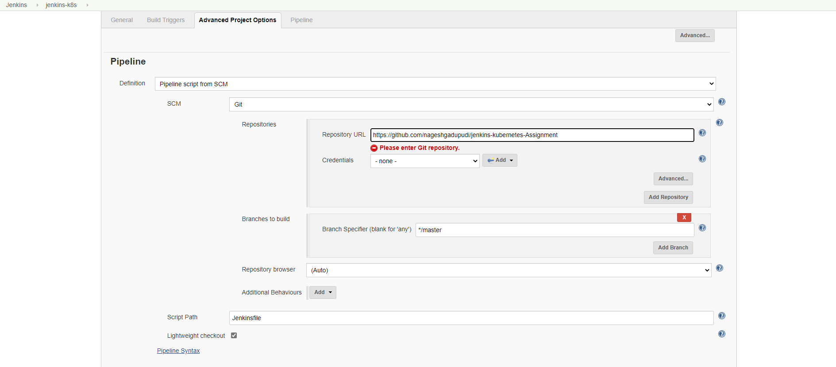

6. Now run the Jenkins pipeline it will take the commands from Jenkins file from which is checkout by github.

7. Now we will go to Kubernetes server and check weather our service is deployed

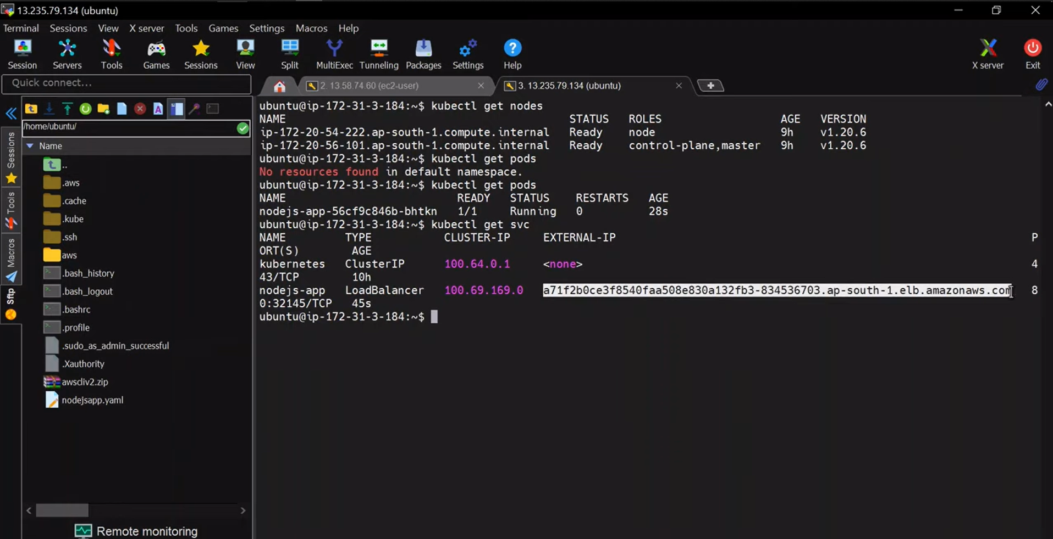

8. copy the link and paste in any browser.

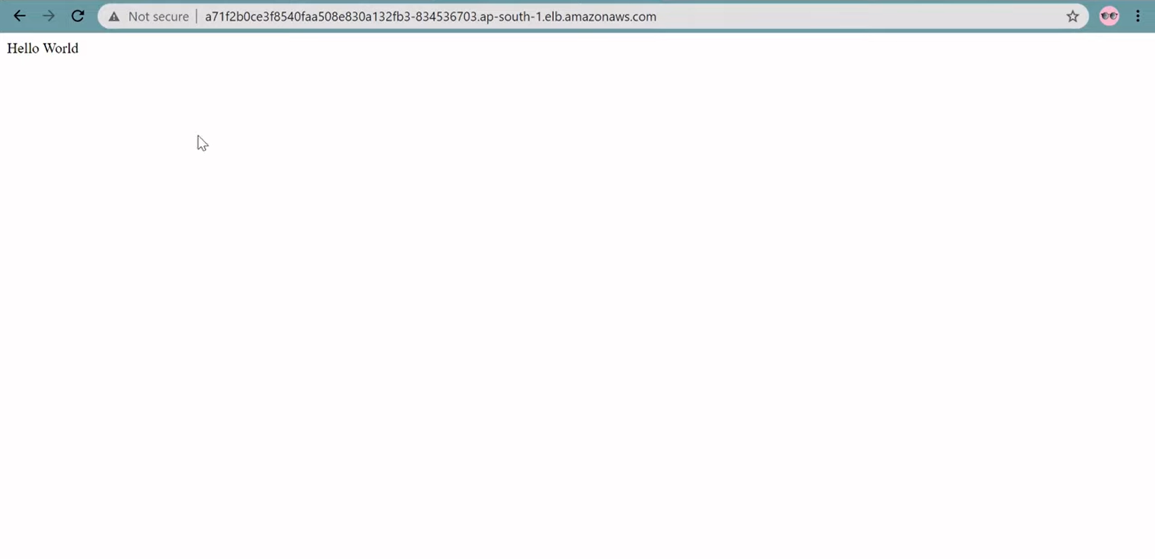

Finally our application deploy successfully.